**IoT applications in agriculture and healthcare**

**Theme of hackathon:** Hyper connected enterprises enabling smarter communication

* The way it is related is that with our product we are able to connect the modern day agriculture and healthcare business owners directly to their product or consumer.

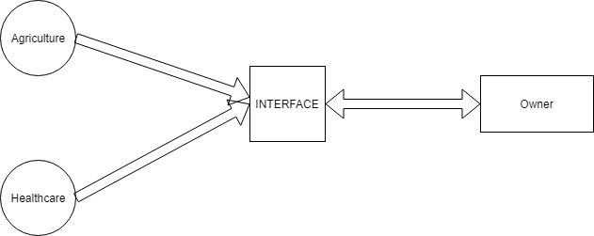

**Agriculture:**

Agenda: To help the farm/land owners who want to monitor the health of their crops on their land either through physical presence and a mobile app based AR or satellite based image analysis.

* All the data is collected from the plants with respect to the sensor data using Arduino to get required data and parse it to the cloud.
* This data is then used by the IoT device to analyze the data and produce desired results that can be called as accepted data wither to be displayed on the end result screen or to determine the extent of health of the crops
* The presentable data is then shown virtually on a screen when augmented and pointed towards the surface of the soil where the plants are growing.

Uses: . Business owners want to track the health of their crops in real time to know of its future or existing potential

Target Audience: All the people from technologically moderate countries that have abundance of agriculturak practices like Hong Kong, China, Phillipines, etc

**Healthcare:**

**Tech Stack:**

* IoT
* AI
* AR
* Cloud
* App and Web dev(UI)

**Work distribution:**

* IoT- Aditya and Mohith(if required)
* AR- Rajshekar
* AI –Nirvan and Mohith
* Cloud and UI -Mohith

**Timeline:**

